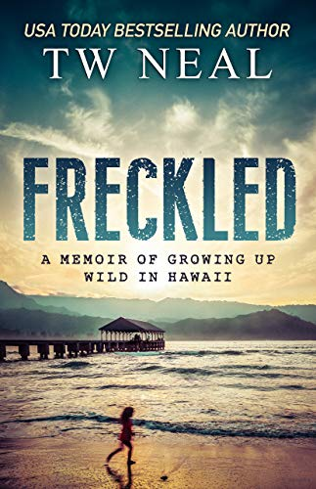
February 19, 2019 – Freckled: A Memoir of Growing up Wild in Hawaii by TW Neal
Born in 1965 to hippie surfer parents who just want to ride waves, use substances, and hide from society, red-headed Toby grows up as one of only a few hundred Caucasian “haole” people on the rugged, beautiful North Shore of Kauai, Hawaii. Toby’s idealistic parents, breaking away from high achieving families, struggle with mental health and addiction issues as they try to live according to their own rules. Despite the hardship and deprivations of life on Kauai, they return again and again to an island whose hold on them is more powerful than any drug, as sensitive and resilient Toby clings to a dream of academic achievement and a “normal” life. Living in tents and off the land without electricity or communication with the outside world, Toby escapes into reading and imagination to deal with racial harassment and indifferent parenting.

March 19,2019 - Where the Crawdads Sing by Delia Owens
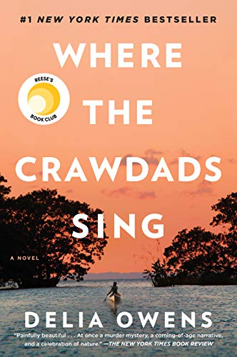
Where the Crawdads Sing is at once an exquisite ode to the natural world, a heartbreaking coming-of-age story, and a surprising tale of possible murder. Owens reminds us that we are forever shaped by the children we once were, and that we are all subject to the beautiful and violent secrets that nature keeps. Sensitive and intelligent, the “Marsh Girl” has survived for years alone in the marsh that she calls home, finding friends in the gulls and lessons in the sand. Then the time comes when she yearns to be touched and loved. When two young men from town become intrigued by her wild beauty, Kya opens herself to a new life--until the unthinkable happens.

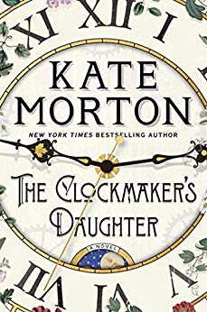
April 16 - The Clockmaker's Daughter: A Novel by Kate Morton
Told by multiple voices across time, The Clockmaker's Daughter is a story of murder, mystery, and thievery, of art, love and loss that cast their shadows across generations, set in England from 1860’s to present. And flowing through its pages like a river, is the voice of a woman who stands outside time, whose name has been forgotten by history, but who has watched it all unfold: Birdie Bell, the clockmaker's daughter.

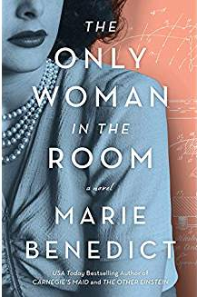
May 21 - The Only Woman in the Room by Marie Benedict
A powerful novel based on the incredible true story of the glamour icon and scientist whose groundbreaking invention revolutionized modern communication. Her beauty almost certainly saved her from the rising Nazi party and led to marriage with an Austrian arms dealer. would listen to her. he Only Woman in the Room is a masterpiece.

Sept 17 – Ready Player One by Ernest Cline
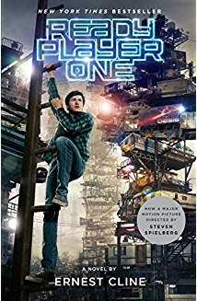
In the year 2045, reality is an ugly place. The only time teenage Wade Watts really feels alive is when he's jacked into the virtual utopia known as the OASIS. Wade's devoted his life to studying the puzzles hidden within this world's digital confines—puzzles that are based on their creator's obsession with the pop culture of decades past and that promise massive power and fortune to whoever can unlock them.
Now a major motion picture directed by Steven Spielberg

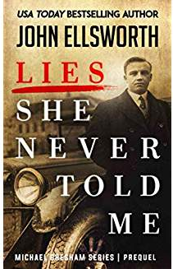
Oct 15 - Lies She Never Told Me: A Michael Gresham Prequel (Michael Gresham Legal Thrillers Book 10) by John Ellsworth
This is the story of Michael Gresham's heritage, beginning with his father's father. The book features mob wars in 1920's Chicago; World War II invasions and POW camps; romance between powerful men and beautiful women; the most infamous mass murder in 1960's Chicago; and the complete growing-up story of Michael Gresham himself, from young boy to young lawyer. The book recounts the first meeting between Michael and his famous investigator Marcel in Operation Desert Shield when both young men are soldiers on the track of Saddam Hussein.

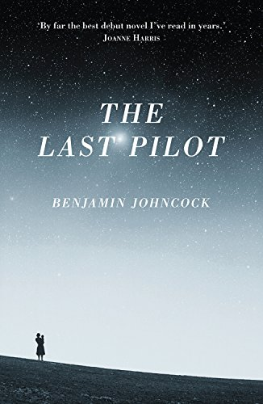
Jan 21, 2020 – The Last Pilot by Benjamin Johncock
The Last Pilot is a breathtaking debut novel of the space race and of one man's courage in the face of unthinkable loss. 1940s America: Jim Harrison is a test pilot in the United States Air Force, one of the exalted few. He spends his days in a precarious dance with death above the Mojave Desert and his nights at Pancho's bar. Set against the backdrop of one of the most exciting and emotionally charged periods in American history, The Last Pilot is a powerful story of of an everyday hero, tested to the limits, physically and mentally.

